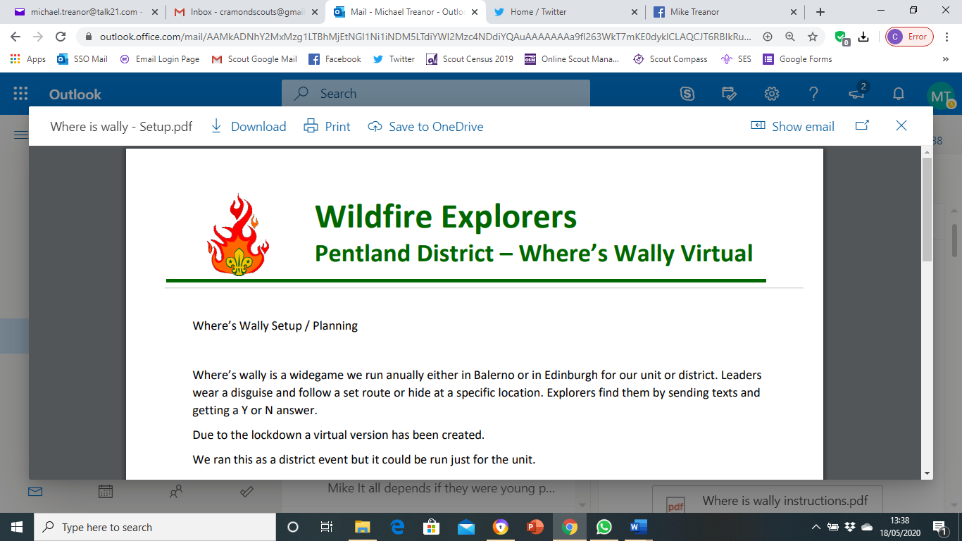

*How the Wildfire Explorers are Surviving Lockdown.*

When the coronavirus crisis first hit us, we did not know what to do. Our social lives that we depended on so much had been stripped off us. But luckily our explorer leaders came to the rescue. They set up an online chat which enabled us to socialise with our friends while remaining within the governments social distancing guidelines. We then proceeded to meet every Friday at our regular meeting times using an online video call. During these sessions we reflected on the current situation and how we were all coping with lockdown. We also played a variety of games one being photo roulette- where we would send photos of ourselves as babies and we would have to guess who each photo was of.

Pre lockdown camp

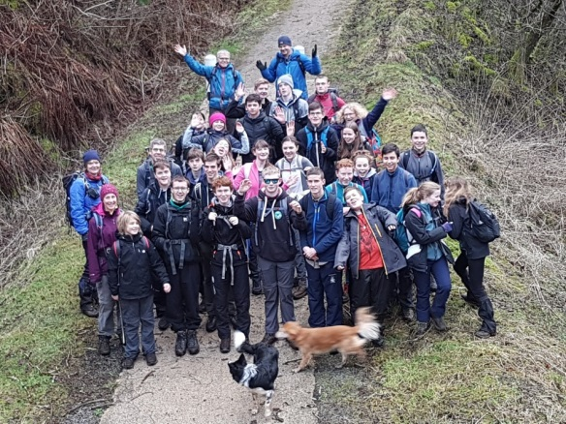A few weeks into this routine we were due to host a district night (where all the nearby explorer units would join us for an evening of activities) but unfortunately this could not happen in the way we wanted it to due to the current circumstances. Nevertheless, we were determined to find an alternative way of running the evening, so we decided to make it a totally virtual. We began the night with an online video call where we met everyone from the other units and our leaders explained the set up for the night. The original plan had us doing a “Where’s Wally” night which would have involved us searching for “Wally” in teams across Edinburgh following clues. Instead, we were then split into about a dozen teams (using group-chats to communicate) with mixed members from different units. Each team was assigned different explorer leaders aka the “Wally” who would take the place of a random stranger in a specific location on google maps- street view. The team of explorers would then ask yes or no questions to the “Wally” to help locate their whereabouts in Edinburgh. It was a great evening where we got to meet new people and have fun without even being in the same room. We have our explorer leaders to thank for the night being such a hit.

Pre lockdown hike

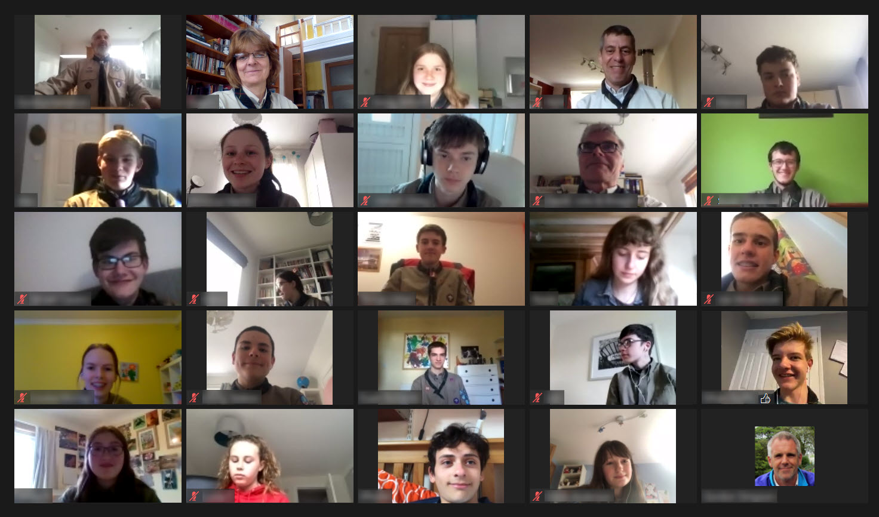

Wildfire Virtual video call

We are continuing to meet every week, sharing some laughter and positivity in this tough period. Although this time is uncertain, one thing is for sure: Explorers on a Friday.

For details of Where’s Wally Virtual – see here – insert document with these three pages



1. **Where’s Wally Setup / Planning**

Where’s wally is a widegame we run annually either in Balerno or in Edinburgh for our unit or district. Leaders wear a disguise and follow a set route or hide at a specific location. Explorers find them by sending texts and getting a Y or N answer. Due to the lockdown a virtual version has been created. We ran this as a district event but it could be run just for the unit.

* Invite other sections using OSM invite.
* Each leader to get parental consent for use of online video call and messaging apps to allow us to follow Scout guidelines on use of social media."
* "Each leader provides a list of names & contact details to Admin."

We had

* 51 explorers participating from 5 different units, 2 different districts.
* 11 Wallys a backup Wally and Admin, all PVG’d leaders.

Create an Online message group for each team

Add Admin, Wally & Backup Wally for each group.

Add explorers (After above 3 leaders in the group so safeguarding maintained)

Paste Explorer instructions into group

Paste link to online video call into group giving details of date and time.

Online video call – Introduce the event. Let everyone know it’s difficult to do things online, everyone can have problems so just relax and ask for help if needed. Explain rules reading from explorer instruction document. Send all back to online message groups.

Admin – cycle through each group, check replies are pasted as replies no just typed in. Check progress of each team. Identify which teams need more help and let wally know to help more. Give thumbs up to teams doing well. If a wally is slow help them answer questions.

After time up explorers and wallys are called back through online message to online video call by pasting online video call link into the chat and asking all to resume.

We bought £5 amazon gift vouchers as prizes and sent them out to explorers in winning team after announcing results. Thanked all the wallys and brought session to a close.

1. **Leader Instructions**

Where – Inside the purple line, Pentland District google map link below.

https://drive.google.com/open?id=1mMzdz6pY2J5XmI-wXmN9m0_4zxNT8n-U&usp=sharing

Wally Instructions to be completed In Advance

1) Recommended setup for Wally is Online video chat running on phone or PC with headset and camera plus Online message running preferably in online message web on a pc but direct from phone works fine also. You will need access to google maps and street view ideally on a pc but a tablet could also be used.

2) Go to google street maps by clicking on google maps in locations you have been given (listed at the bottom) and clicking again on real world image that appears at the bottom of the page. (See map below)

3) Move around by clicking in direction you want to go. Identify what you can see, familiarise yourself with the map around that location.

Wally Instructions to be discussed with all Wally’s

1) You will be in a team online message group along with a small group of explorers an admin and backup wally.

2) Say hi to your explorer team. Explorers will ask questions, you can only answer – Y, N or ?

a. Try to answer each question as a reply rather than just typing a new text.

3) They might ask are you west of Gillespie crossroads, are you in Balerno, can you see the Co-op. If you answer ‘?’ Explorers should ask you the same question in another way. The idea is for explorers to find you so you are trying to help them, if you are more in Balerno than anywhere else answer Y . Your answer should be a ‘reply’ to explorer post not just typed in so everyone knows which question the answer relates to. Answer questions that you know the answer without looking at the map first, answer questions with answer Yes before other questions.

4) Wally will get lots of simultaneous questions so your trying to home them home in on you as quickly as possible. If explorers ask very specific questions at the start remind them to look at wider area.

5) If they only ask are you in ‘Balerno’ type questions remind them they can narrow down the area much quicker with ‘Are you South of A70’ type questions.

6) To find you, explorers need to describe where you are in detail or what you are wearing so that you know they have found you. When this happens say You found me! I have no teleported to a new location find me again.

7) If they are stuck or need help give them clues. A group of 4 or 5 explorers as a team will find between 3 and 8 wallys based on our experience. The first Wally will take twice as long as explorers work out a strategy

that works for them.

8) Explorers may want to setup their own calls between themselves to discuss what they are doing

1. **Explorer Instructions**

Wally is hiding in Pentland District, see google map link below.

https://drive.google.com/open?id=1mMzdz6pY2J5XmI-wXmN9m0_4zxNT8n-U&usp=sharing

Note – Street view does not work in this map, start a new google map in a separate window.

Try to work as a team, ‘chat’ amongst yourselves then ask “Wally , …..…..”Wally does really want to be found and is trying to help you but Wally can only reply with a Y, N or ? Once you describe Wally’s outfit correctly, he will teleport to the next hiding place for you to find.

See Instructions for more details & tips.

Instructions

1) Start by trying to work out which part of the district Wally is in using google map to see street names or roads.

2) Once you have worked out which street or part of a street Wally is in switch to street view. Note the map with Pentland district marked on it does not have street view functionality, you will need a separate google map window.

3) To look at Street view, Click on a specific point on google map and you get to see an image at the bottom of the screen. Click on this image to see the street view. Look and move about in the ‘real world’

4) To show you have found Wally you need to describe what he/she is wearing or doing.

5) At time up you will be told in online message group to reconnect to the online video call meeting.

Tips

1) In busier places you need to find a specific location using the map before going to street view as there will be a lot of people to choose from so it would take a long time to guess which one.

2) You can ask questions like ‘Are you North of Currie scout Hall?’, ”Are you in Colington” , “are you inside the bypass” , “Are you North of the A70” or ‘Are you in a park’ . If you get a “?” It is because Y or N doesn’t really answer the question, try asking a more specific question.

3) Sometimes Wally can hide from certain angles. If you are near a road junction try moving to all sides of the junction and looking around at each location, the view may change.

4) If you have access to a PC/Laptop you may want to use that to look at google maps.

5) If you want to use online message on the PC/Laptop you can within a browser once linked to your phone.

6) Street view does not just go along roads. The whole length of the canal is also covered in detail.