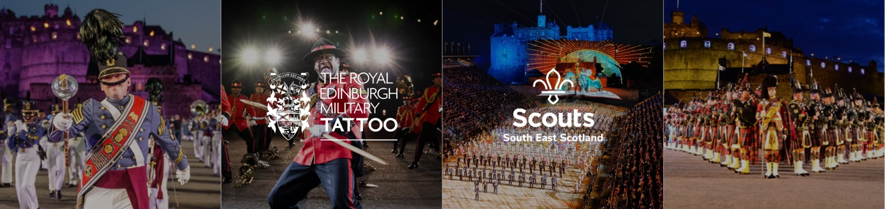

THE ROYAL EDINBURGH MILITARY TATTOO 2026
South East Scotland Scouts — Volunteer Programme Seller Application

Are you an enthusiastic and confident Explorer Scout or Young Leader? If so, we’d love you to be part of the sales team to sell programmes at the Castle Esplanade to the Tattoo’s audience as they go to their seats before the show starts.
You will need to be available for about six or seven nights between 6th–29th August 2026. You will be on duty from 7:15pm until approximately 9:45pm on weeknights and from 4:45pm–9:45pm on a Saturday.
Applications must be received no later than Sunday 21st June 2026. Completed applications can be submitted to sue.timmins@sesscouts.org.uk.
As part of the application, we will also require a passport-sized photograph (full face), attached with your form.
Please save the completed form with the applicant’s name in the file name, e.g. “B.Simpson Volunteer Form” if returning via email.

1 Personal Details

Full Name |  | Date of Birth |  | Scout Group / Section
Email Address |  | Phone Number |  | Postcode
Address

Parent / Guardian Email (required if under 18)

2 Availability — Tick every date you are available
Please indicate your availability for every date. You will be allocated approximately 6–7 nights based on your selections.
Thu 6 Aug | Fri 7 Aug | Sat 8 Aug | Mon 10 Aug | Tue 11 Aug | Wed 12 Aug | Thu 13 Aug
Fri 14 Aug | Sat 15 Aug | Mon 17 Aug | Tue 18 Aug | Wed 19 Aug | Thu 20 Aug | Fri 21 Aug
Sat 22 Aug | Mon 24 Aug | Tue 25 Aug | Wed 26 Aug | Thu 27 Aug | Fri 28 Aug | Sat 29 Aug

3 Declaration

Due to the nature of the event, photographs, video and audio of Explorers/Leaders are likely to be taken by members of the public, broadcasters and event organisers. If you do not wish photographs to be taken, regretfully we are unable to progress your application. By signing below I confirm the information above is accurate.
Signed (Parent / Guardian / Leader) |  | Date

Return to sue.timmins@sesscouts.org.uk · Questions: Sue Timmins 07954 386571 · File name: e.g. “B.Simpson Volunteer Form 2026”

